# VSB ENGINEERING COLLEGE , KARUR ELECTRONICS AND COMMUNICATION ENGINEERING

ASSIGNMENT - I

TITLE : Industry Specific Intelligent Fire Management

System

NAME : Dharshini SG

DOMAIN NAME : Internet Of Things MENTOR NAME : Janani S

# Assignment Topic :

Make a Smart Home in Tinkercad using 2+ sensors,LED,Buzzer in the single code and Circuit .

# Required Materials :

* Arduino UNO R3
* Ultrasonic Distance Sensor
* PIR Sensor
* DC Motor
* Micro Servo
* LED
* Breadboard

# Circuit Design :

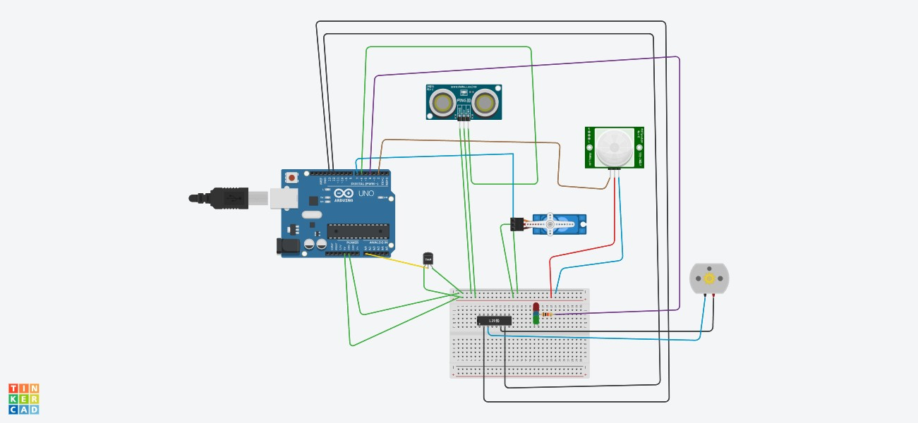

**Code :**

#include<Servo.h> int us = 6;

int servo = 7; Servo servo1;

void setup() { Serial.begin(9600); servo1.attach(servo); pinMode(2,INPUT); pinMode(4,OUTPUT);

pinMode(11,OUTPUT); pinMode(12,OUTPUT); pinMode(13,OUTPUT); pinMode(A0,INPUT); digitalWrite(2,LOW); digitalWrite(11,HIGH);

}

void loop() {

long duration, inches, cm;

pinMode(us, OUTPUT); digitalWrite(us, LOW); delayMicroseconds(2); digitalWrite(us, HIGH);

delayMicroseconds(5); digitalWrite(us, LOW); pinMode(us, INPUT); duration = pulseIn(us, HIGH);

inches = microsecondsToInches(duration);

cm = microsecondsToCentimeters(duration); servo1.write(0);

if(cm < 30)

{

servo1.write(120);

Serial.println("A Person Arrived, Door is Opening ");

delay(2000);

}

else

{

servo1.write(0); Serial.println("Door is Closed ");

}

int pir = digitalRead(2);

if(pir == HIGH)

{

digitalWrite(4,HIGH); delay(3000);

}

else if(pir == LOW)

{

digitalWrite(4,LOW);

}

float value=analogRead(A0);

float temp=(((value/1024)*5.0199)-0.5)*100;

Serial.print("temp is "); Serial.println(temp); delay(3000);

if(temp > 20)

{

digitalWrite(12,HIGH); digitalWrite(13,LOW);

}

else

{

digitalWrite(12,LOW); digitalWrite(13,LOW);

}

}

long microsecondsToInches(long microseconds) { return microseconds / 74 / 2;

}

long microsecondsToCentimeters(long microseconds) { return microseconds / 29 / 2;

}

# OUTPUT :

